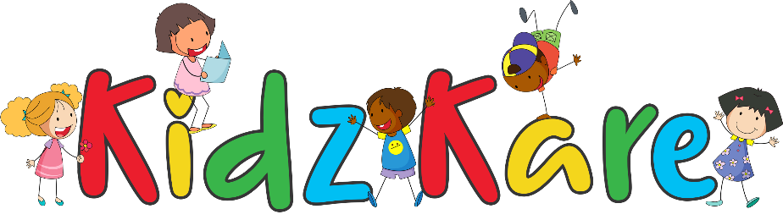
“Where quality child care and education is A Breeze”

RENTAL AGREEMENT

This agreement is made between KIDZ KARE, hereinafter called the Lessor and

________________________________________________hereinafter called the Lessee.

Kidz Kare equipment is received for rental purposes only. Lessee shall keep and maintain
the equipment in good repair and shall replace all damaged and/or broken parts immediately. Any parts not returned shall be charged to Lessee at present selling price. Lessee shall not loan, sub-let, mortgage or in any other manner dispose of same to any person without the written consent of owner. Any personal injuries or property damage suffered by any person using this equipment shall be assumed by the Lessee and no liability whatsoever shall attach to the Lessor.

Lessee agrees to indemnify the Lessor against all loss, damage, expense and penalty arising from any action on account of any injury to person or property occasioned by the operation, handling or transportation of the leased property during the rental period or while the property is in the possession or control of the Lessee.

The Lessee assumes all risks inherent in the operation and use of the rented equipment. The Lessee agrees to assume responsibility and hold Lessor harmless from, and release Lessor from any and all claims for damage to property and bodily injury (including death), or for loss of time and inconvenience resulting from the operation or possession of rented equipment, whether or not it be claimed or found that such damage or injury resulted in whole or in part from Lessor’s negligence, from the defective condition of the rented equipment or from any cause.

…………………………… ………………………….
Lessor’s Signature Lessee’s Signature

Date: ____/_____/_____

P.O. BOX PW 5177, STONEY GROUND, ANGUILLA AI-2640
T: 1 (264) 584 3495/ (941) 343 3068 E: kidzkareanguilla@gmail.com W: www.kidzkareanguilla.com

